# Develop ML model with Amazon SageMaker

## Workflow of ML model development

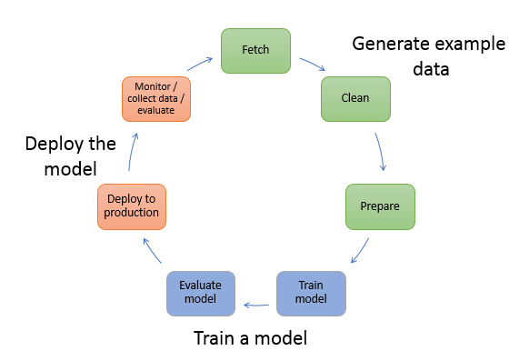

### Generate example data

1. Fetch the data that are publicly/privately available.
2. Preprocess the data—perform additional data transformations to improve performance.

### Train a model

1. Training the model— select an algorithm and use computing resources ranging from a single, small general-purpose instance to a distributed cluster of GPU instances.
2. Evaluate the model to determine its accuracy.

### Deploy the model

Integrate the model into the application to generate inferences in real time and at scale.

## Amazon SageMaker workflow

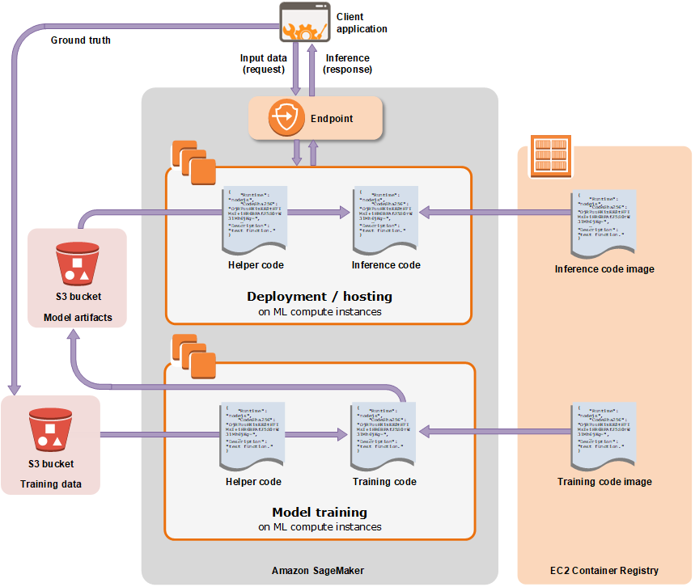

### Generate data

1. Jupyter notebook to preprocess the data

### Crate a training job and train the model

* 1. S3 bucket stores the training data;
  2. The computing resources needed,
  3. S3 bucket stores the output of the job
  4. Docker registry path where the training code is stored.

### Deploying a Model

1. The S3 path where the model artifacts are stored
2. Docker registry path where the inference code is stored.
3. Create an HTTPS endpoint

## Example

### Step 1: Create a Jupyter Notebook and Initialize Variables

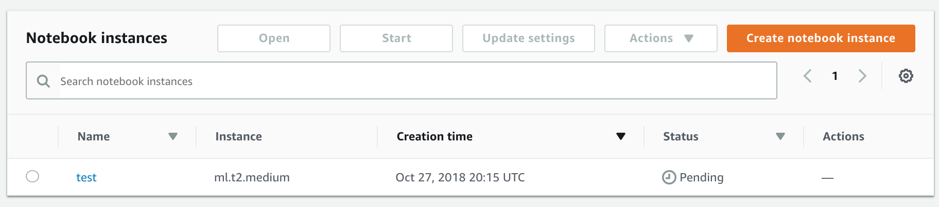

### Step 2: Download, Explore, and Transform the Training Data

1. Download the MNIST dataset to your Amazon SageMaker notebook instance

%%time  
import pickle, gzip, numpy, urllib.request, json  
  
*# Load the dataset*  
urllib.request.urlretrieve("http://deeplearning.net/data/mnist/mnist.pkl.gz", "mnist.pkl.gz")  
with gzip.open('mnist.pkl.gz', 'rb') as f:  
 train_set, valid_set, test_set = pickle.load(f, encoding='latin1')

1. Transform the Training Dataset and Upload It to S3

%%time  
from sagemaker.amazon.common import write_numpy_to_dense_tensor  
import io  
import boto3  
  
bucket = '*sagemaker365*'  
data_key = 'kmeans_lowlevel_example/data'  
data_location = 's3://{}/{}'.format(bucket, data_key)  
print('training data will be uploaded to: {}'.format(data_location))  
  
*# Convert the training data into the format required by the SageMaker KMeans algorithm*  
buf = io.BytesIO()  
write_numpy_to_dense_tensor(buf, train_set[0], train_set[1])  
buf.seek(0)  
  
boto3.resource('s3').Bucket(bucket).Object(data_key).upload_fileobj(buf)

### Step 3: Train a Model

1. Choose the Training Algorithm

Specify the registry path of the Docker image that contains the training code.

Specify algorithm-specific parameters.

The input and output S3 bucket.

1. Create a Training Job

Option1: Use the high-level Python library provided by Amazon SageMaker

from sagemaker import KMeans  
  
data_location = 's3://{}/kmeans_highlevel_example/data'.format(bucket)  
output_location = 's3://{}/kmeans_highlevel_example/output'.format(bucket)  
  
print('training data will be uploaded to: {}'.format(data_location))  
print('training artifacts will be uploaded to: {}'.format(output_location))  
  
kmeans = KMeans(role=role,  
 train_instance_count=2,  
 train_instance_type='ml.c4.8xlarge',  
 output_path=output_location,  
 k=10,  
 data_location=data_location)

%%time  
  
kmeans.fit(kmeans.record_set(train_set[0]))

Option2: Use the SDK for Python

### Step 4: Deploy the Model to Amazon SageMaker

Option1: Deploy the Model to Amazon SageMaker Hosting Services

Option2: Deploy the Model to Amazon SageMaker Batch Transform

### Step 5: Validate the Model

Option1: Use the high-level Python library provided by Amazon SageMaker.

Option2: Use the SDK for Python.

Time spent: 90 min